SU Forget Network Android

How to disconnect and remove your wifi network
- Navigate to your phones settings, once there you will see something similar to below. Note each phone may be slightly different.
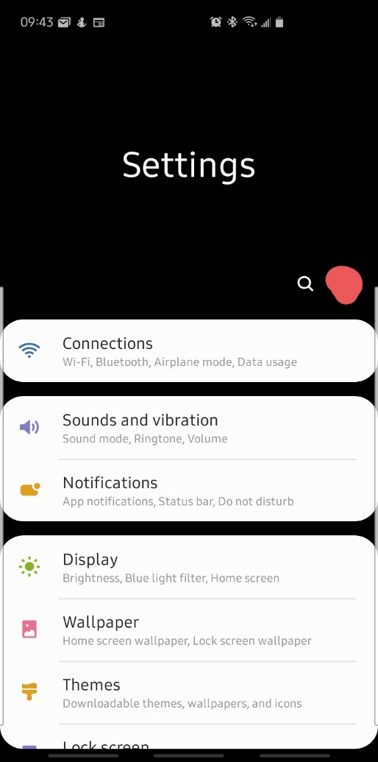

- Within your settings tap or click on the menu that is labeled either Connections, Network or Wifi. You will see a screen that will be somewhat similar to below.

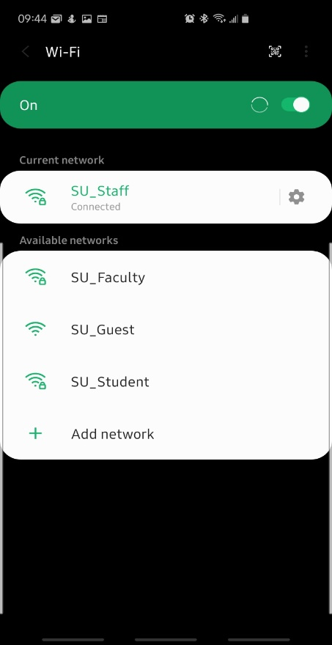

- Next to the currently connected wifi network select the gear it I symbol to bring up the network settings.
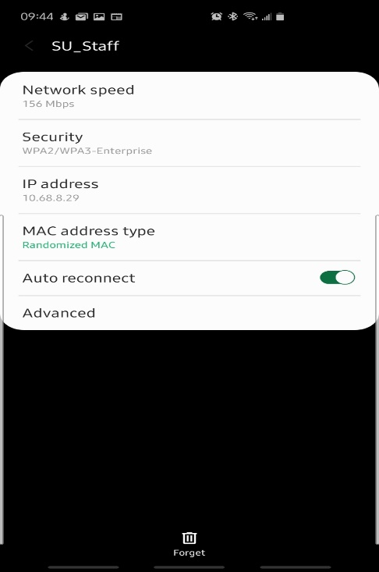
- Press on the Forget button on this screen to remove the wifi connection from your mobile device.

Reconnecting to the Wifi
- After forgetting your wifi network you should be brought back to the list of wifi networks to connect to. Select the wifi network appropriate to you.
- Upon selecting your wifi network to connect to you will be brought to a similar following screen.
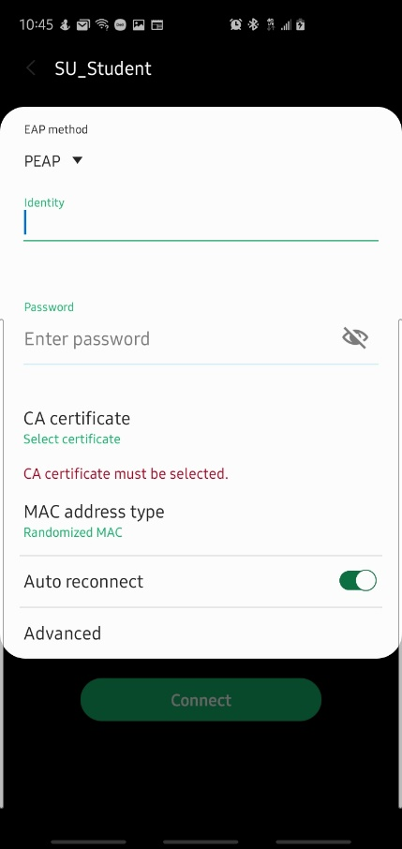

- For the blank field read the following:
  - Identity: Portal Username
  - Password: Portal Password
  - CA Certificate: Select Don’t Validate
- Once your information has been entered press connect. You should now be connected to the campus wifi.

