SU Email Removal and Addition

Removing your mobile email
- Open up the application on your phone you use to view you email.

- At the top you should see three lines or 3 dots, something similar to below.

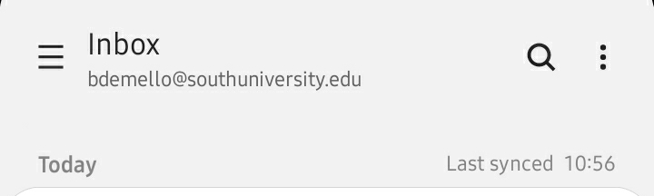

- On the menu that pops out press the gear symbol in one of the corners.

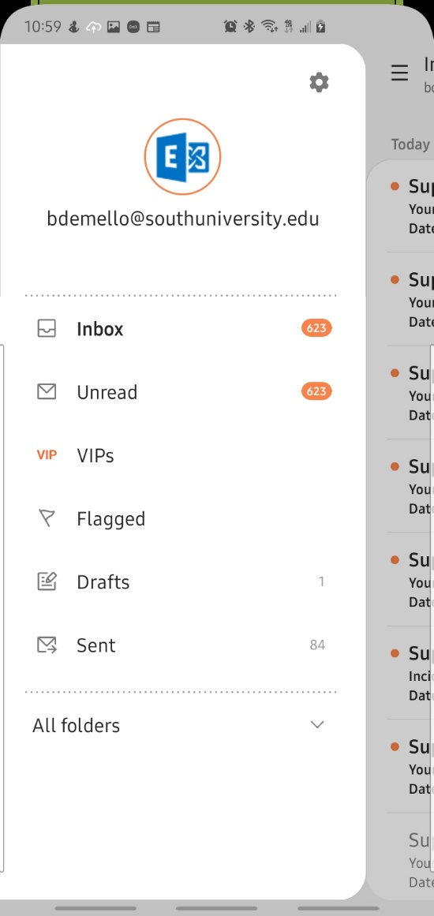
- On the new screen after pressing the gear you’ll see a list of options. At the very top should be your email address, press and you will be brought to another menu.

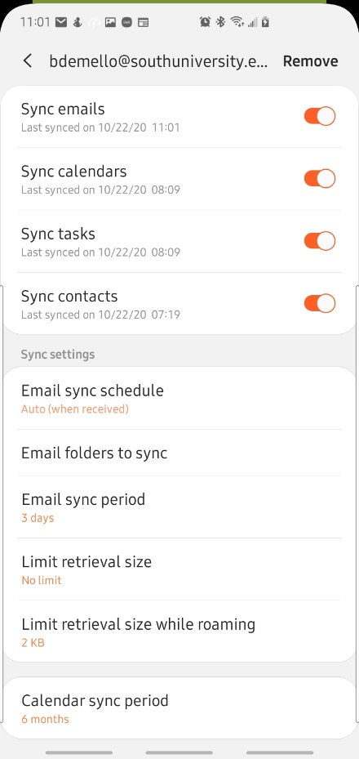

- On this next menu press Remove, this will either be in one of the corners or at the very bottom of the screen; You may need to scroll all the way down to see it at the bottom.

- Another warning pop-up will come up letting you know what will be removed when you remove the account. Press on the button that says remove.

- Once your account in removed you should be brought back to a screen to set up your email again.

Setting up mobile email

- On the main screen you should see a number of boxes for email services, select the one labeled Office 365.

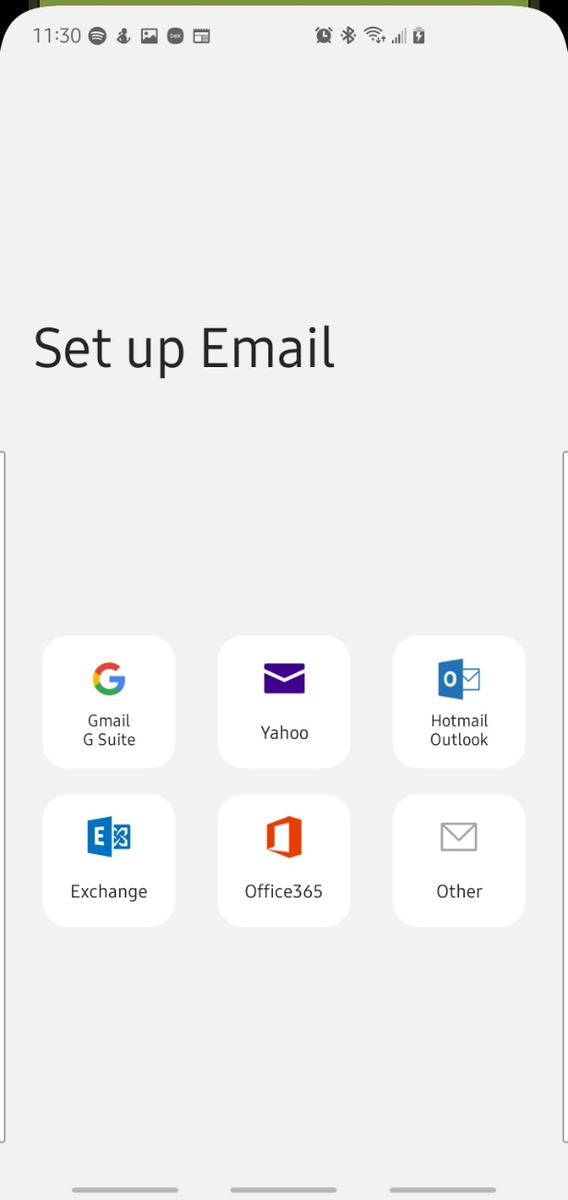

- On the next screen you will then enter your email address of your university email and your password.

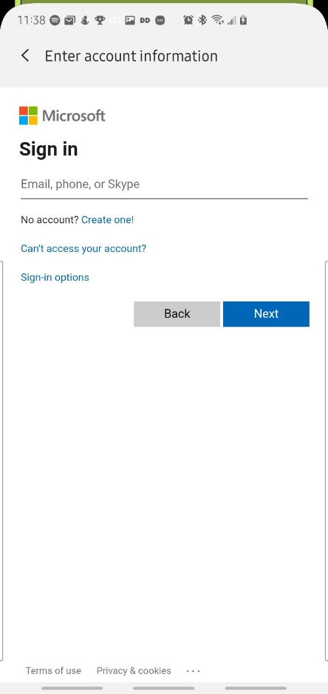

- Once you have entered in your email address and password you should be all signed in to your email on your mobile device.

- If you receive a message saying that you are blocked, don’t worry you are signed into your account and IT will just need to unblock your phone.

