Note Outlook for iOS requires iOS 8.0 or higher.
Do you have Outlook for iOS installed on your device?
  - If it's not installed on your device, download Outlook for iOS from the Apple Store, open it, swipe through the introductions, and then tap Get Started.
If it is installed on your device, open the app:
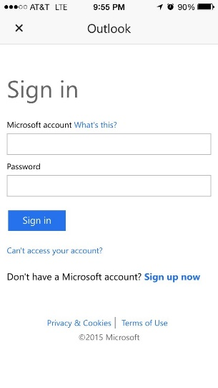
- Tap Settings > Mail, Contacts, Calendars >Add Account.
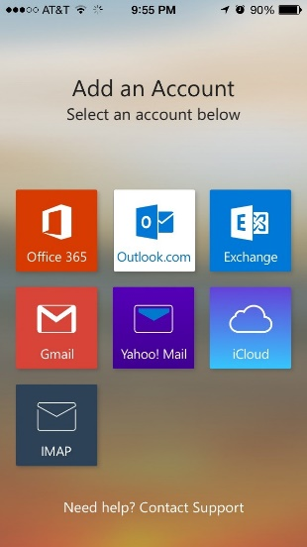

- In the Add Account page, select the mail you want to add:
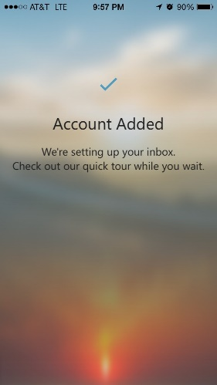
  - Tap Exchange
- Enter your full email address, for example bob@stu.southuniversity.edu
- Enter your password
- Tap Sign in.
- The account will be added, and Outlook for iOS will begin to sync to the email account.
Note If you get a time-out message, your password or other information might be incorrect. Retype the information, and then try again.

- Tap Settings > Mail, Contacts, Calendars > Accounts > Add account. 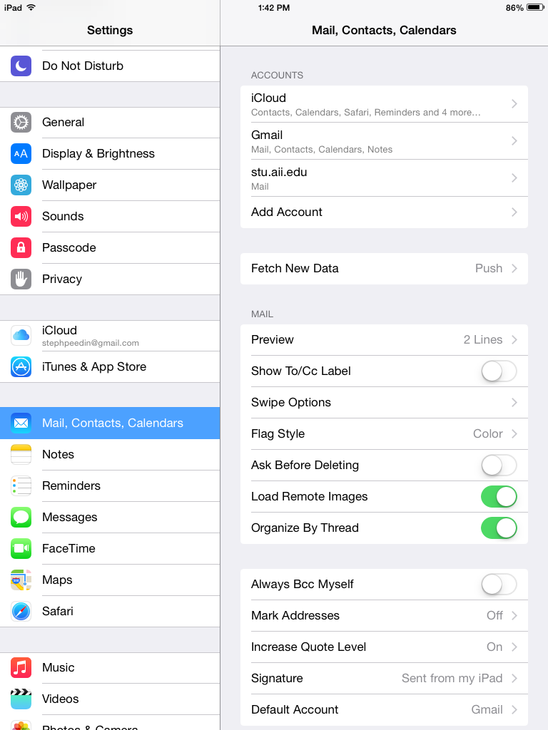

- In the Add Account page, tap Exchange.
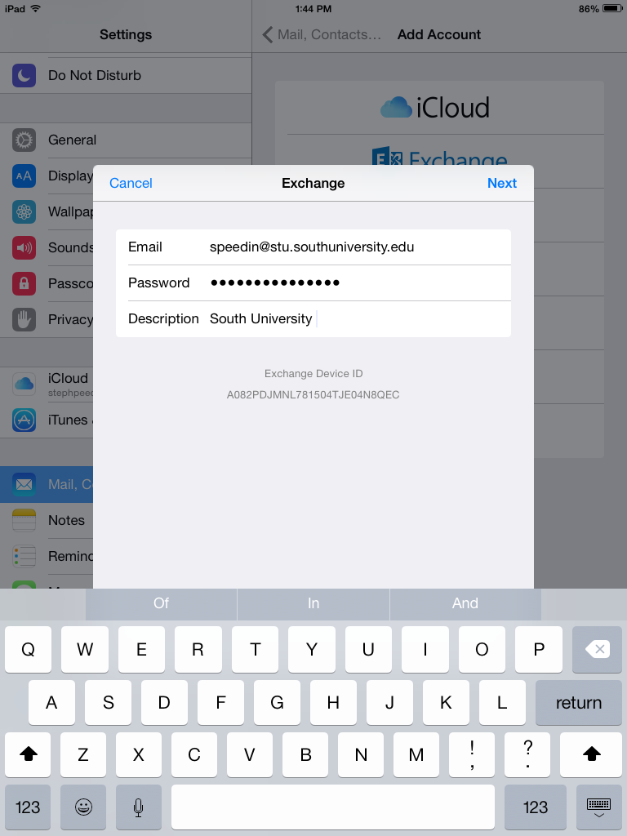
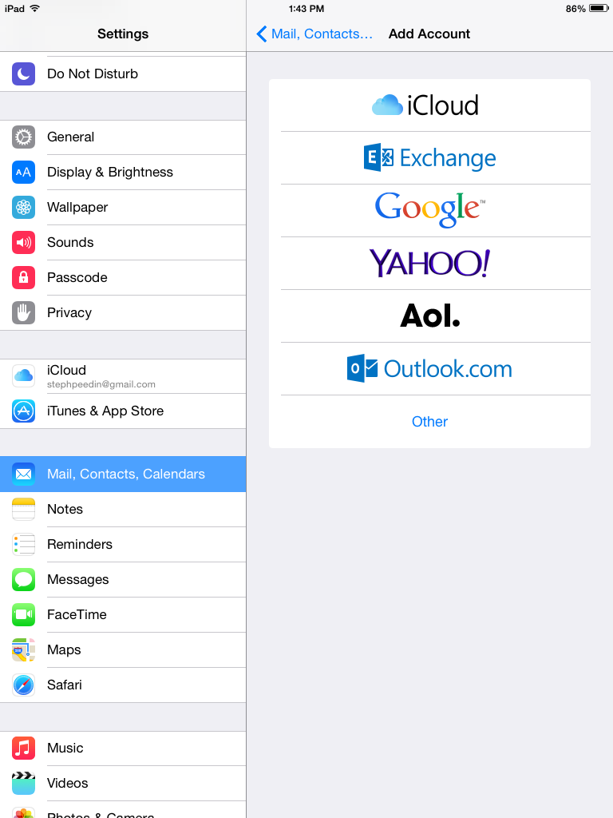
- Enter your full email address, for example bob@stu.southuniversity.edu, and your password, and then tap Next.
If the device can't find your settings, you need to add them. If you have an Office 365 Exchanged email account in Server, enter outlook.office365.com, and then add your Username and Password.

- By default, Mail, Contacts, and Calendar information are synchronized. Tap Save. 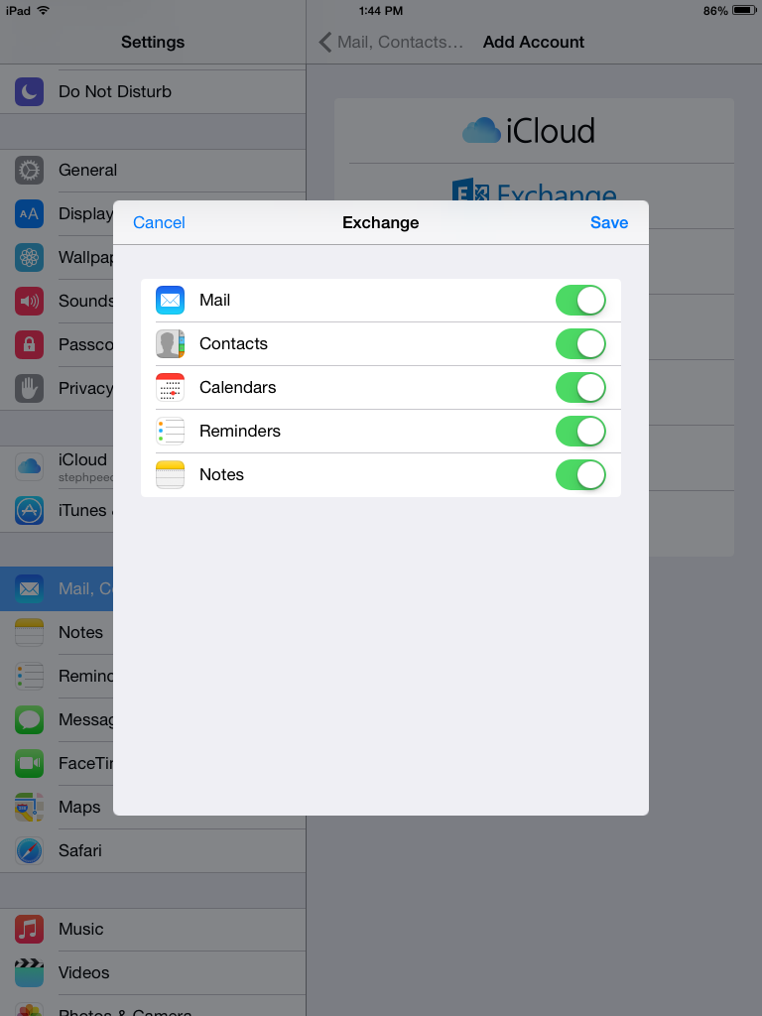
- Verify that the account add was successful. Should look similar to the shot below: 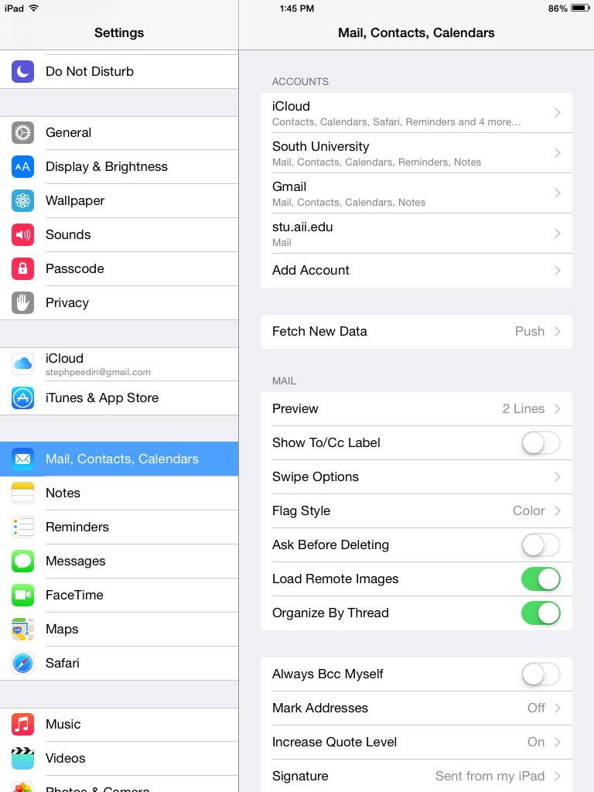
Note If you get a time-out message, your password or other information might be incorrect. Retype the information, and then try again.
Note You might need to need to wait ten to fifteen minutes after you set up your account before you can send or receive email.

