NOTE Outlook for Android requires a device running Android 4.0 or later.
Do you have Outlook for Android installed on your device?
If it's not installed on your device, download Outlook for Android from the Google Play Store. Open the app. If you want an introduction, tap Product Tour, or tap, Get Started.
If it is installed on your device, open the app:
- Tap the navigation control at the bottom of your device, or tap More > Settings > Add Account.
- On the Add An Account page, select the mail account you want to add:
- Tap Exchange (since you are connecting your school account in Office 365, which is an Exchange-based mail account.)

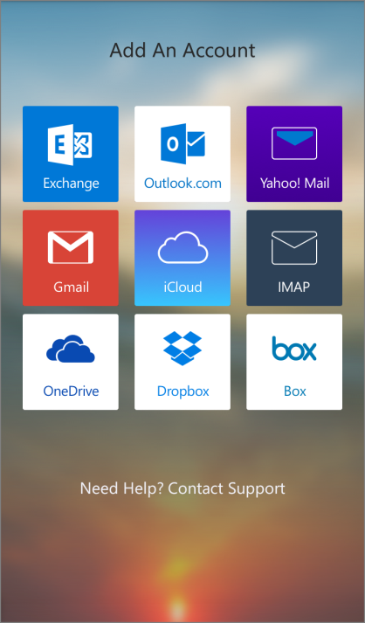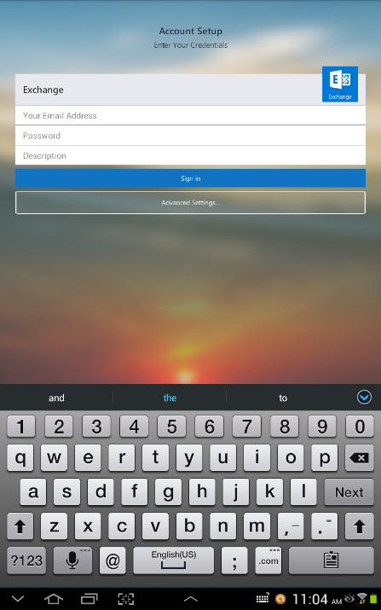
- Enter your full email address, for example bob@stu.southuniversity.edu, type your password, and then tap Sign in.
- The account will be added, and Outlook for Android will begin to sync to the email account.

