ANDROID OUTLOOK SETUP

- Enter your South University email into the field labeled “Email Address” and tap “Continue.”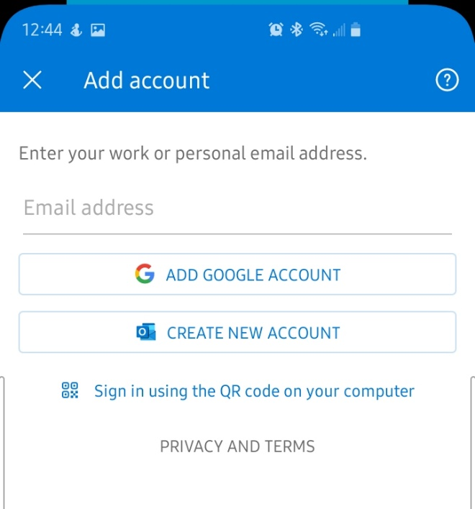
- After entering your password, deselect this box to prevent personal accounts from being added into the outlook app and press “Next.”
username@southuniversity.edu

- Next, allow outlook to activate device administrator, and select “Activate.” After this step, your email will be available on your mobile Android device.
