EMAIL FOR MOBILE PHONE USERS

- After setting up your email on your computer and checking “Set up email on my mobile phone, too,” a browser window will open with this page. You can use this page and have a download link sent to your phone/scan a QR code. You can also search for the outlook app in your device’s application store and download it directly if you do not get to this screen.
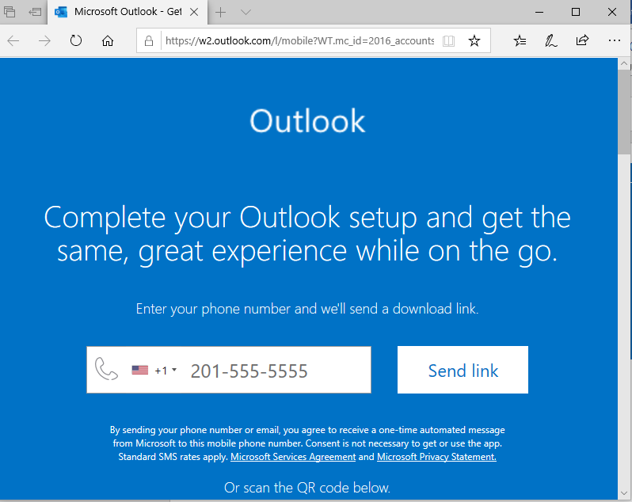
- You should be directed to your App store to download the app.
- After installing the app, open and enter your SU Email and password to sign in.

